MAA Awards, Prizes, and Lectures

Writing Awards determined by committees who submit their recommendation to the secretary by April 15:

- Allendoerfer (Mathematics Magazine)
- Halmos-Ford Award (Monthly)

- Trevor Evans (Math Horizons)
- Pólya (College Mathematics Journal)

Writing awards and lectures recommended to the Board by committees who submit their recommendation along with citation to the secretary by May 1 for:

- Beckenbach Book Prize
- Chauvenet Prize
- Euler Book Prize
- Robbins Prize

- Hedrick Lecturer
- Leitzel Lecturer
- Pólya Lecturer
- Hasse Prize (due October 15, even years)

Nominations for teaching, research, writing, and service awards: Send to the secretary (secretary@maa.org) by the dates given.

- Mary P. Dolciani Award for distinguished contribution to the mathematical education of K-16 students in the United States or Canada, September 1
- Henry Alder Award for Distinguished Teaching by a beginning mathematics faculty member, October 1
- John and Annie Selden Prize for research in Mathematics Education (odd years), October 1
- Daniel Solow Author’s Award that recognizes author or authors of undergraduate teaching materials, October 1
- Meritorious Service Awards, recommendations from sections, October 15
- Gung and Hu Award for Service to Mathematics, December 1
- Haimo Award for Distinguished College or University Teaching, March 1
- AMS-MAA-SIAM Morgan Prize for Undergraduate Research, to the AMS Secretary by June 30

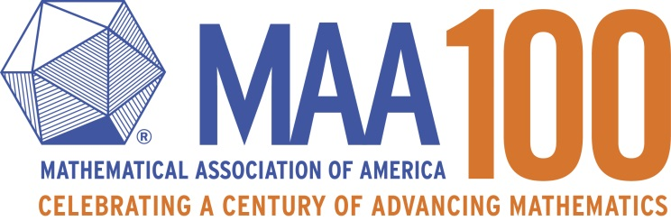

Committee Chairs as of February 1, 2016

Committee | Chair | Chair’s Email
Alder Award | Eric Egge |  | eegge@carleton.edu
Allendoerfer Award | Megan Kerr |  |  | mkerr@wellesley.edu
Beckenbach Book Prize | Daniel Hrozencik |  |  | dhrozenc@csu.edu
Chauvenet Prize | Susan Colley |  |  | sjcolley@math.oberlin.edu
Euler Book Prize | Dennis Deturck |  |  | deturck@math.upenn.edu
Falconer Lecturer | Carlos Cartillo-Chaves |  |  | ccchavez@asu.edu
Halmos-Ford Award | Tanya Leise |  |  | tleise@amherst.edu
Gung and Hu Award | Douglas Ensley |  |  | deensley@ship.edu
Haimo Award | Thomas Hagedorn |  |  | hagedorn@tcnj.edu
Hedrick Lecturer | Ravi Vakil |  |  | vakil@math.stanford.edu
Leitzel Lecturer | Laurie Heyer |  |  | laheyer@davidson.edu
Meritorious Service | Recommended by MAA Sections
Merten Hasse Prize | Thomas Marshall Fiore |  |  | tmfiore@umd.umich.edu
Morgan Prize | Carla Savage, AMS Secretary |  |  | ams_secretary@ncsu.edu
Pólya Award | Natacha Fontes-Merz |  |  | fontesnc@westminster.edu
Pólya Lecturer | Colin Adams |  |  | Colin.Adams@williams.edu
Robbins Prize | David Bressoud |  |  | bressoud@macalester.edu
Solow Award  Selden Prize | Bud Brown  Rina Zazkis |  |  | ezbrown@math.vt.edu mkinzel@boisestate.edu
Trevor Evans Award | Ryan Garibaldi |  |  | skip@garibaldibros.com
Dolciani Award | David Stone |  |  | dstone@georgiasouthern.edu
MAA Secretary | Barbara Faires |  |  | secretary@maa.org
AMS Secretary | Carla Savage |  |  | ams_secretary@ncsu.edu

